**Internship Documentation :**

**Company Name : Akash Technolab**

**Internship technology : PHP**

**Submitted By : Ronakbhai Bharatbhai Bhalala**

**Date : 26/05/21**

**Task 1 :**

**Practice :**

**Program 1 : Use of Echo statement.**

<!DOCTYPE html>

<html>

<head>

<title>

Task-1 : Echo

</title>

</head>

<body>

<h2>Simple Php Prgram.</h2><br>

<?php

echo "<h1>My First Program in PHP.</h1>";

?>

</body>

</html>

**Output:**

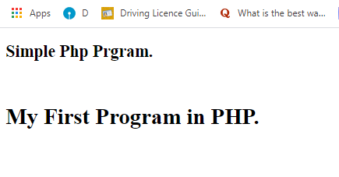

**Program 2 : Use of If-else statement.**

<!DOCTYPE html>

<html>

<head>

<title>

Task-1 : ifelse

</title>

</head>

<body>

<h2>If-else in PHP.</h2><br>

<?php

$a = 20;

if($a==10)

{

echo "A is 10.";

}

elseif($a < 10)

{

echo "A is < 10.";

}

else

{

echo "A is > 10.";

}

?>

</body>

</html>

**Output:**

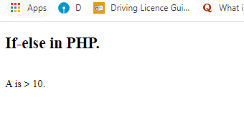

**Program 3 : Use of Switch statement.**

<!DOCTYPE html>

<html>

<head>

<title>

Task-1 : SwitchCase

</title>

</head>

<body>

<h2>Switch Case in PHP.</h2><br>

<?php

$a = 3;

switch($a){

case 1 :

echo "one";

break;

case 2 :

echo "two";

break;

case 3 :

echo "three";

break;

default :

echo "Please Select 1-3";

}

?>

</body>

</html>

**Output:**

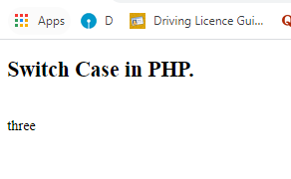

**Program 4 : Use of Variable.**

<!DOCTYPE html>

<html>

<head>

<title>

Task-1 : variable

</title>

</head>

<body>

<h2>Assign Variable in PHP.</h2><br>

<?php

//variable

$a=50;

$b=40;

$c= $a+$b;

echo "<br/>Value of A is $a.<br/>Value of B is $b.<br/> Addition of A and B is $c.";

?>

</body>

</html>

**Output:**

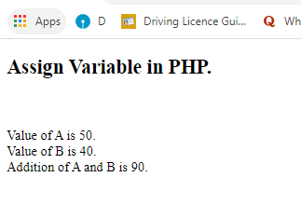

**Program 5 : Array Example**

<?php

$cars = array("Volvo", "BMW", "Toyota");

echo "I like " . $cars[0] . ", " . $cars[1] . " and " . $cars[2] . ".";

?>

**Output:**

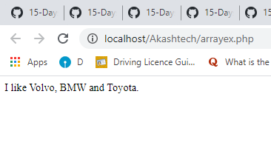

**Program 6 : Use of date function.**

<?php

echo "Today is " . date("Y/m/d") . "<br>";

echo "Today is " . date("Y.m.d") . "<br>";

echo "Today is " . date("Y-m-d") . "<br>";

echo "Today is " . date("l");

?>

**Output:**

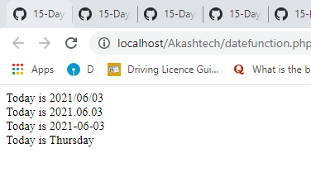

**Program 7 : integration of php and html.**

<?php

echo "Welcome To PHP";

echo "<h1>I am h1 in PHP</h1>";

?>

<html>

<body>

Welcome to HTML code

<?php

echo "I am PHP inside HTML";

?>

</body>

</html>

**Output:**

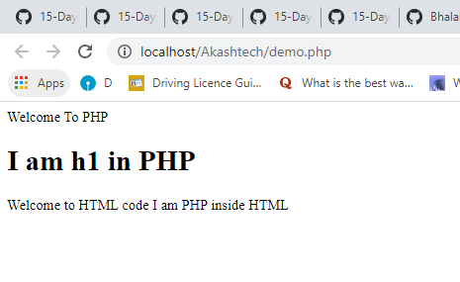

**Program 8 : Functions in php**

<?php

function writeMsg() {

echo "Hello world!";

}

writeMsg(); // call the function

?>

**Output:**

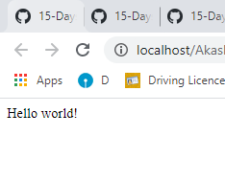

**Program 9 : Math function in php**

<?php

echo "<h1>Pi Function</h1>";

echo (pi());

echo "<h1>Min Max Function</h1>";

echo(min(0, 150, 30, 20, -8, -200) . "<br>");

echo(max(0, 150, 30, 20, -8, -200));

echo "<h1>Squre Root Function</h1>";

echo(sqrt(64));

echo "<h1>Round Function</h1>";

echo(round(0.60));

echo(round(0.49));

echo "<h1>Random Function</h1>";

echo(rand(10, 100));

?>

**Output:**

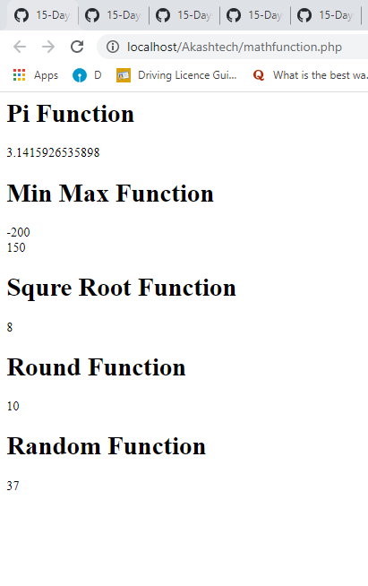

**Program 10 : String functions**

<?php

echo "<h1>String Length</h1>";

echo strlen("Hello world!");

echo "<h1>Word Count</h1>";

echo str_word_count("Hello world!");

echo "<h1>String Reverse</h1>";

echo strrev("Hello world!");

echo "<h1>String Replace</h1>";

echo str_replace("world", "Ronak", "Hello world!");

?>

**Output:**

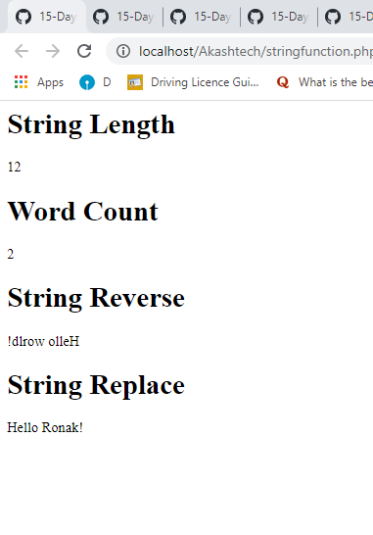

**Task 2 :**

**Code:-**

**1. Write a PHP program to print factorial of a number.**

<?php

$num =5;

$factorial =1;

for ($x=$num; $x>=1;$x--)

{

$factorial = $factorial * $x;

}

echo "factorial of $num is : $factorial";

?>

**Output:**

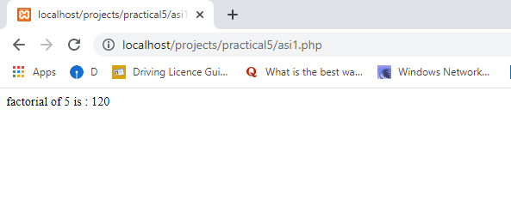

**2. Write a PHP program to check palindrome number.**

<?php

function palindrome($n){

$number = $n;

$sum = 0;

while(floor($number)) {

$rem = $number % 10;

$sum = $sum * 10 + $rem;

$number = $number/10;

}

return $sum;

}

$input = 1235321;

$num = palindrome($input);

if($input==$num){

echo "$input is a Palindrome number";

} else {

echo "$input is not a Palindrome";

}

?>

**Output:**

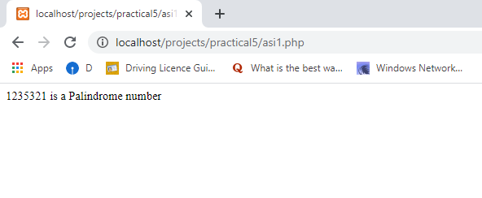

**3. Write a PHP program to find area of triangle.**

<?php

$base = 10;

$height = 15;

echo "Area of triangle with base $base and height $height= " . ($base * $height) / 2;

?>

**Output:**

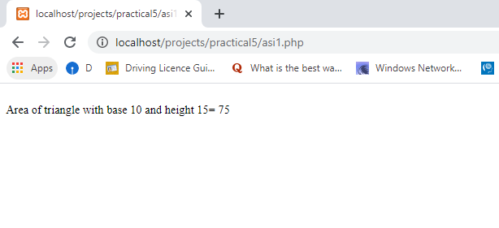

**4. Write a PHP program to print the table of number.**

**Program : 1**

<?php

define('a', 7);

echo $a;

for($i=1; $i<=10; $i++)

{

echo $i*a;

echo '<br>';

}

?>

**Output:**

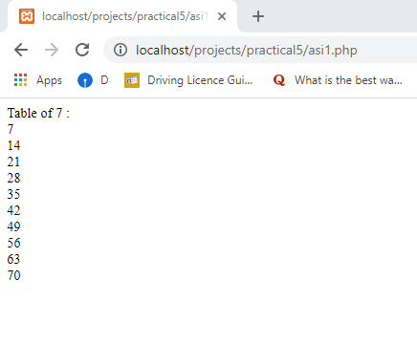

**Program : 2**

<?php

//driver code

$n=6;

for($i =1; $i<=10;++$i)

{

echo $n,"*",$i,"=",$n * $i , "</br>";

}

?>

**Output:**

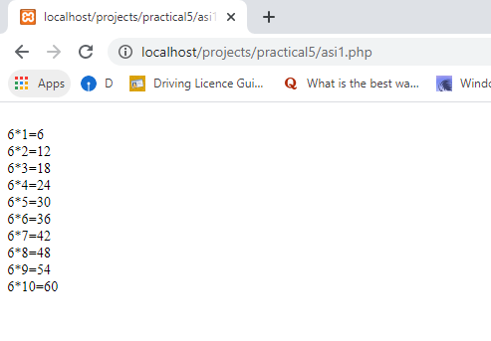

**5. Write a PHP program to print sum of digits.**

<?php

$num = 14597;

$sum=0; $rem=0;

for ($i =0; $i<=strlen($num);$i++)

{

$rem=$num%10;

$sum = $sum + $rem;

$num=$num/10;

}

echo "Sum of digits 14597 is $sum";

?>

**Output:**

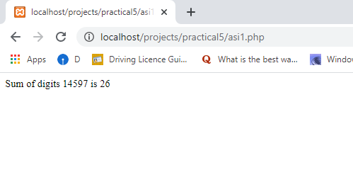

**6. Write a PHP program for find leap year.**

<!DOCTYPE html>

<html>

<head>

<title>

Task-2 : LeapYear

</title>

</head>

<body>

<h2>Leap year Program in PHP.</h2><br>

<?php

$p = 2060;

if ($p % 400 == 0) {

echo "$p is a Leap Year";

}

elseif ($p % 100 == 0) {

echo "$p is not a Leap Year";

}

elseif ($p % 4 == 0) {

echo "$p is a Leap Year";

}

else{

echo "$p is not a Leap Year";

}

?>

</body>

</html>

**Output:**

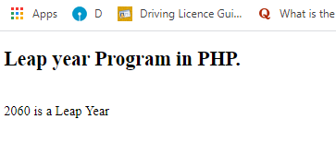

**7. Write a PHP program to print minimum and maximum.**

<!DOCTYPE html>

<html>

<head>

<title>

Task-2 : minmax

</title>

</head>

<body>

<h2>Minimum and Maximum Program in PHP.</h2><br>

<?php

$max = 40;

$min = 10;

if ($max < $min) {

echo "$max is greater than $min";

}

else{

echo "$min is smaller than $max";

}

?>

</body>

</html>

**Output:**

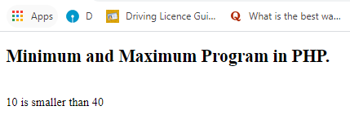

**8. Write a PHP program to print odd even.**

<!DOCTYPE html>

<html>

<head>

<title>

Task-2 : Odd/Even

</title>

</head>

<body>

<h2>Odd or Even Program in PHP.</h2><br>

<?php

$input = 45;

if($input % 2 == 0){

echo "$input is Even";

}

else{

echo("$input is Odd");

}

?>

</body>

</html>

**Output:**

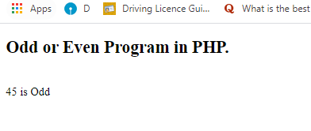

**9. Write a PHP program to perform subtraction.**

<!DOCTYPE html>

<html>

<head>

<title>

Task-2 : Subtraction

</title>

</head>

<body>

<h2>Subtraction Program in PHP.</h2><br>

<?php

$x=60;

$y=15;

$z=$x-$y;

echo "Subtraction of $x-$y=<b>$z.</b>";

?>

</body>

</html>

**Output:**

